Hi Mitch,

It was really nice to meet all 4 of you yesterday, especially Ginger! She is such a sweet dog and it is easy to see why you fell in love with her. Below is a summary of our discussion as well as our plan moving forward. I would suggest giving this 4-5 weeks to see how things go and keeping a journal to make sure that your impressions of any changes are accurate and objective. After that, you might consider a second appointment, depending upon Ginger's progress.

Ginger is definitely guarding some of her resources (couch and toys) from your other dog (sorry, I forget his name!) and is also simply not that social of a dog. Both of these attributes are completely normal and are not likely to change very much.

In fact, guarding resources from other dogs is not technically resource guarding, it is more of a natural dog behavior that humans don't like. Our primary job is to reduce the risk of intense resource guarding actions (such as biting) so as to keep harmony in your multi-dog household. We talked about approaching this from three perspectives: management, counterconditioning and obedience.

The couch is going to become Ginger's safe spot. We need to give her ZERO reasons to guard it from her canine housemate through effective management. We are going to do this by restricting his easy access to the couch, while still maintaining Ginger 's ability to come and go. We can do this by using gates such as these. I have a dog with similar guarding tendencies as Ginger (the dog in the crate) and have created this set up. Her crate is her safe spot and she can come and go as she pleases. The gate allows this, but also keeps my other dog (the husky in the background) at a distance where she will not growl at him.

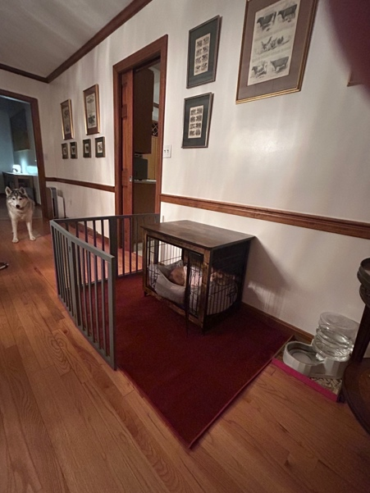

We are going to couple this management change with some obedience work for both of your dogs. You are going to work on a "Go to place" (his bed or mat) command with your household dog so that if he gets too close to Ginger, you can instruct him to go to his mat. If Ginger can safely jump on and off the couch, I would also suggest teaching her a "go to place" command, using the couch as her place.

A second management change we are going to make is to put away all of the toys unless you are there to keep an eye on things and each dog is in their place; the couch for Ginger, the bed/mat for your other dog.

Additionally, we are going to try and help Ginger feel a bit more comfortable around her housemate with some basic counterconditioning by treating her and/or offering her affection whenever the house dog is in the living room. Similarly, when he leaves, the treats and/or affection leave.

If Ginger stiffens or growls when he is around, that means that we have asked too much of her and she is not comfortable. You will need to increase the distance between Ginger and your other dog until she is comfortable.

Since we are taking something away from the dogs (free access to toys 24X7) it will be important to replace it with something else like a new puzzle game, hiding treats around the house for Ginger, the sheep ball game or just an extra short sniff walk on a long lead. Keep it simple and easy for you!

As you implement this plan, make sure that you see improvements. Ginger should relax and guard less as the need to guard diminishes, but that does not always happen. By restricting toy access, we are making the toys more valuable, so it is really important that you do the management and obedience work and that you carefully observe the changes in Ginger

Concurrently, you can also start another stream of obedience work to help both of your dogs with food guarding. Simply put both of them in a sit next to each other and practice alternating giving treats to each dog as the other waits. I did a little of this work yesterday in the kitchen. If this does not work, put more distance between the dogs. You will need 2 people for this exercise if this is the case.

Please let me know if you have any issues along the way. Also, if you don't require a follow up appointment, please send me a quick email letting me know that things are going well!

Thanks again for the opportunity to work together and for being a veterinarian. We really need you!!!!

Best regards,
Meghan

